TITLE – BUDGET TRACKER

A DESIGN PROJECT REPORT SUBMITTED

IN PARTIAL FULFILMENT FOR THE AWARD OF

THE DEGREE OF

BACHELOR OF TECHNOLOGY

IN

DEPARTMENT OF CSE - (DS)

# Submitted by

|  |  |
| --- | --- |
|  |  |
| B SAI CHARAN | 21071A6702 |



VALLURUPALLI NAGESWARA RAO VIGNANA JYOTHI INSTITUTE OF ENGINEERING AND TECHNOLOGY

An Autonomous Institute, NAAC Accredited with ‘A++’ Grade (CGPA: 3.73/4.0)

NBA Accredited for CE, EEE, ME, ECE, CSE, EIE, IT B.Tech. Programmes

Approved by AICTE, New Delhi, Affiliated to JNTU-H, Recognised as “College with Potential for Excellence” by UGC

Vignana Jyothi Nagar, Pragathi Nagar, Nizampet (S.O), Hyderabad TS 500 090 India

2023-2024

i

|  |
| --- |
| CENTRE FOR PRESENCING AND DESIGN THINKING  VALLURUPALLI NAGESWARA RAO VIGNANA JYOTHI INSTITUTE OF ENGINEERING AND TECHNOLOGY  An Autonomous Institute, NAAC Accredited with ‘A++’ Grade (CGPA: 3.73/4.0) NBA Accredited for CE, EEE, ME, ECE, CSE, EIE, IT B.Tech. Programmes  Approved by AICTE, New Delhi, Affiliated to JNTU-H, Recognised as “College with Potential for Excellence” by UGC  Vignana Jyothi Nagar, Pragathi Nagar, Nizampet (S.O), Hyderabad TS 500 090 India              CERTIFICATE  This is to certify that the project titled BUDGET TRACKER is being submitted, by SAI CHARAN B (21071A6702, CSDS) in partial fulfilment of the requirement for the award of degree of Bachelor of Technology to the Centre for Presencing and Design Thinking at the Vallurupalli Nageswara Rao Vignana Jyothi Institute of Engineering and Technology is a record of bonafide work carried out by them under our pedagogy. The results embodied in this Project have not been submitted to any other University or Institute for the award of any degree.    Project Mentor  Mr.Ch.Naveen Reddy  VNRVJIET  Hyderabad            Internal Examiners External Examiners  ii |

# ABSTRACT

Expense Tracker is a web application designed to streamline the management of personal and business finances. Boasting an intuitive interface, users can effortlessly track, categorize, and analyze their expenses. Real-time updates enhance the experience, ensuring that users are always up-to-date with their financial activities. Robust reporting features empower individuals and small businesses to gain better control over their financial data.

This comprehensive solution offers seamless navigation through its responsive design, guaranteeing a consistent user experience across various devices. Whether on a desktop, tablet, or smartphone, Expense Tracker facilitates convenient and efficient expense management. With its user-friendly features, the application is ideal for individuals seeking better financial organization and small businesses aiming for improved financial control. The web app's versatility allows users to access and manage their financial data anytime and anywhere, making it a valuable tool for those on the go.

iii

|  |  |
| --- | --- |
| TABLE OF CONTENTS    Details of Contents    Abstract    Questionnaire and Responses    List of Figures    Chapter 1: Introduction to Problem  1.1 Objective  1.2 Introduction  1.3 Scope of the project    Chapter 2: Discover and define  2.1 Empathy Interview  2.2 Persona  2.3 User Needs    Chapter 3: Customer service experience  3.1 Service experience cycle  3.2 Pain point address    Chapter 4: Ideation  4.1 Ideation Tools  4.2 Outcome of Ideation Phase    Chapter 5: Prototype model  5.1 latent Needs Addressed  5.2 Evaluation of prototype Based on Desirability, Feasibility& Viability    Chapter 6: Conclusions and Future Scope  6.1 Conclusions  6.2 Future Scope    References                      vii | Page no  iii    viii-xi    v  1      2    3  4      5 5  6  7  7-8  9    10      11 |

# QUESTIONNAIRE

1. How often do you actively track your expenses and manage your budget as a student? (Daily, Weekly, Monthly, Occasionally, Rarely).

1. On a scale from 1 to 10, how confident do you feel about managing your finances effectively as a student? (1 being not confident at all, 10 being extremely confident).

1. What are the biggest challenges you face when it comes to managing your expenses and budget as a student?

1. What specific features or functionalities would you find most helpful in a budget/expense tracker designed for students?

1. How comfortable are you using technology-based solutions (apps, websites) to track your expenses and budget? (Very comfortable, Somewhat comfortable, Not comfortable).

1. Would you prefer a budget/expense tracker that offers personalized financial tips or guidance tailored to students' needs? Why or why not?

1. How important is it for you that a budget/expense tracker has a mobile app version for easy access on-the-go?

1. Have you used any budgeting tools or apps specifically targeted for students before? If yes, what did you like or dislike about them?

1. In what ways do you believe an effective expense tracking system could positively impact your life as a student?

1. What additional resources or features do you think would make

budget/expense tracker more appealing and useful for students like yourself?

RESPONSES FROM INFORMAL

CONVERSATION

Student 1:

Daily

8

Juggling part-time job expenses and study costs

Reminders for bill payments, a budget calculator

Very comfortable

Yes, because guidance would be helpful

Extremely important for easy access

Yes, liked the budgeting tips but disliked the interface

It would help me save more for textbooks and leisure activities Real-time spending notifications, a savings goal tracker.

Student 2:

Monthly

6

Managing impulse purchases and dining out expenses

Expense categorization, weekly spending reports

Somewhat comfortable

No, prefer managing on my own

Moderately important for convenience

Yes, liked the simplicity but lacked customization

It could help me plan better for semester expenses Integration with student discounts and loyalty programs.

Student 3:

Occasionally

9

Keeping track of social activities spending

Budget goal setting, automatic expense categorization

Very comfortable

Yes, it would provide useful insights

Moderately important for on-the-go access

No, never used a student-focused budgeting tool

It could help me allocate funds better for study materials A feature for sharing expenses among roommates.

Student 4:

Weekly

7

Balancing transportation costs with groceries

Customizable budget categories, expense trend analysis

Somewhat comfortable

Yes, personalized tips would be beneficial

Very important for quick updates

No, never tried a student-specific tracker It might assist in managing monthly food expenses A feature for setting spending limits per category.

Student 5:

Rarely

5

Unexpected emergency expenses

Simple interface, expense predictions

Not comfortable

No, prefer managing finances independently

Not very important, prefer desktop access

Yes, found a student budgeting tool too complicated Unsure how it might impact my student life A feature for suggesting cost-saving measures.

Student 6:

Rarely

4

Managing funds without a structured budget

Simple interface, customizable expense categories

Not comfortable

No, prefer handling finances independently

Not very important, prefer desktop access

Yes, but found it too complicated to use Unsure how it might impact my student life A feature for tracking irregular income sources.

Student 7:

Daily

9

Keeping track of textbooks and stationery expenses

Automated bill reminders, budgeting for specific events

Very comfortable

Yes, personalized advice would be beneficial

Extremely important for easy access

Yes, liked the budgeting tools available

It could assist in better managing academic expenses

A feature for setting financial goals

Student 8:

Occasionally

6

Irregular spending due to irregular income

Predictive analysis for expenses, investment guidance

Very comfortable

No, prefer managing finances on my own

Moderately important for access outside home

No, never tried student-focused expense tracking

Unsure how it could impact my finances

A feature for monitoring subscriptions and memberships

Student 9:

Weekly

7

Difficulty in sticking to a planned budget

Expense categorization, monthly savings analysis

Somewhat comfortable

Yes, if it offers actionable advice

Moderately important for flexibility

Yes, but felt it lacked customization

It could help in better planning for leisure expenses

A feature for suggesting cost-cutting measures

Student 10:

Monthly

6

Handling sudden academic-related expenses

Bill payment reminders, expense trend graphs

Somewhat comfortable

No, prefer managing finances without suggestions

Moderately important for convenience

No, never used a student budgeting tool

Unsure how it might impact my student life

A feature for alerting about budget overspending

# CHAPTER 1 INTRODUCTION

1.1 Objective

The objective of the Expense Tracker project is to develop a streamlined and userfriendly application dedicated to efficiently tracking and managing personal and household expenditures. Our goal is to provide individuals with a robust tool that simplifies the process of recording, categorizing, and analyzing expenses, thereby fostering improved financial awareness and planning. The application aims to offer a seamless user experience, leveraging intuitive interfaces and insightful visualizations to empower users in making informed decisions about their finances. Through this project, we strive to contribute to enhanced financial well-being by promoting responsible spending habits and facilitating a more comprehensive understanding of individual budget dynamics.

1.2 Introduction

In the realm of financial management, the challenge of monitoring expenses frequently impedes effective planning, leading to suboptimal financial outcomes. Recognizing this need, our project aims to address the issue by introducing a user-friendly and uncomplicated expense tracker application.

The primary goal is to provide a seamless solution that empowers individuals to effortlessly monitor and manage their expenditures, thereby enhancing overall financial planning. Through the development of this application, we aspire to simplify the process of tracking expenses, offering a practical tool to foster better financial habits. Join us in revolutionizing financial planning by embracing a user-centric approach to expense tracking.

1.3 Scope for the Work

Features that are already implemented:

* User can register to website and login if once registered.
* Interface through which a person can update expenses.
* User can analyze the expenses based on different categories.

Features that are yet to be implemented:

* Adding remainders whenever expenses crosses certain limit.
* Adding features to share the expense details with friends, family etc. ● Improvements are to be done regarding privacy.

CHAPTER 2

# DISCOVER AND DEFINE

2.1 Empathy Review

A Informal conversation has been conducted with students.

2.1.1 Empathy Tool Used – USER

● SAY :

I spend a lot everyday.

I have to time to track expenses manually.

Don’t know how much percent I should spend on what.

* + - THINK :

Why is my expense is so high?

Is there any budget tracking app?

* + - DO :

Check bank statements.

Keep transaction slip for his reference

* + - FEEL :

Unsure

Confused

Curious

Questionnaire:

* + - How often do you actively track your expenses?
    - How confident do you feel about managing your expenses?
    - What are the biggest challenges you face when it comes to managing your expenses and budget?
    - What specific features would you find most helpful?
    - Would you prefer an expense tracker that offers personalized financial tips? ● Have you used any budgeting apps targeted for students before?

2.2 User Needs

User needs are requirements that add value to a product, service or environment for a user. Capturing user needs is a process of engaging users to understand their problems, processes, goals and preferences.

2.2.1 Primary needs:

● Primary need is to provide a convenient way to record expenses, categorizing transactions and Budget planning.

2.2.2 Secondary needs:

● Secondary need is to provide Bill remainders and alerts, Financial reports and analysis.

2.2.3 Latent Needs

● This can be also include security and privacy features, budgeting tools.

CHAPTER 3

# CUSTOMER SERVICE EXPERIENCE

3.1 Service experience cycle

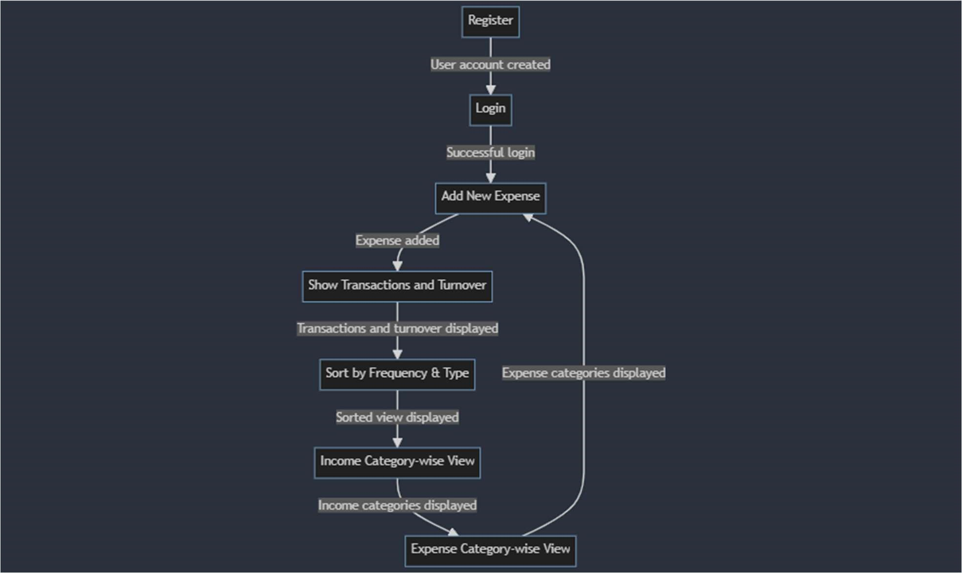

3.2 Pain point Address:

Addressing the Pain Point in the Budget Tracker:

Improved Transaction Input Interface: The budget tracker introduces a more user-friendly transaction input interface. It includes:

* Auto-Categorization: Implement an AI-driven system that automatically categorizes transactions based on spending patterns, reducing the manual effort required.
* Feedback Form: Incorporate a feature where users can submit feedback directly from the app interface.

Real-time Transaction Validation: Enable real-time validation to ensure accuracy:

* Transaction Confirmation: Prompt users to confirm or edit newly added transactions immediately after input, reducing errors.
* Error Detection and consistency: Implement checks for duplicate entries, ensuring data accuracy.

CHAPTER 4

# IDEATION

4.1 Ideation Tool Used - Scamper

Here we used SCAMPER as a Ideation tool.

* SUBSTITUTE:

we aim to substitute the challenges and limitations associated with manual expense tracking and financial planning.

* ADAPT :

The component we would like to change in our problem is the user wasting his/her time in analyzing and understanding expenses.

* MODIFY:

We are focusing on changing the process through which a person can easily update expenses.

* PUT TO OTHER USE:

The target group benefitting from this process is students. It can also be used to analyzing and understanding expenses.

* ELIMINATE:

We would like to eliminate the process of a user wasting his time in searching for online transactions and understanding expenses.

* REARRANGE:

Rearranging is all about thinking what would happen if a part of the problem worked in reverse.

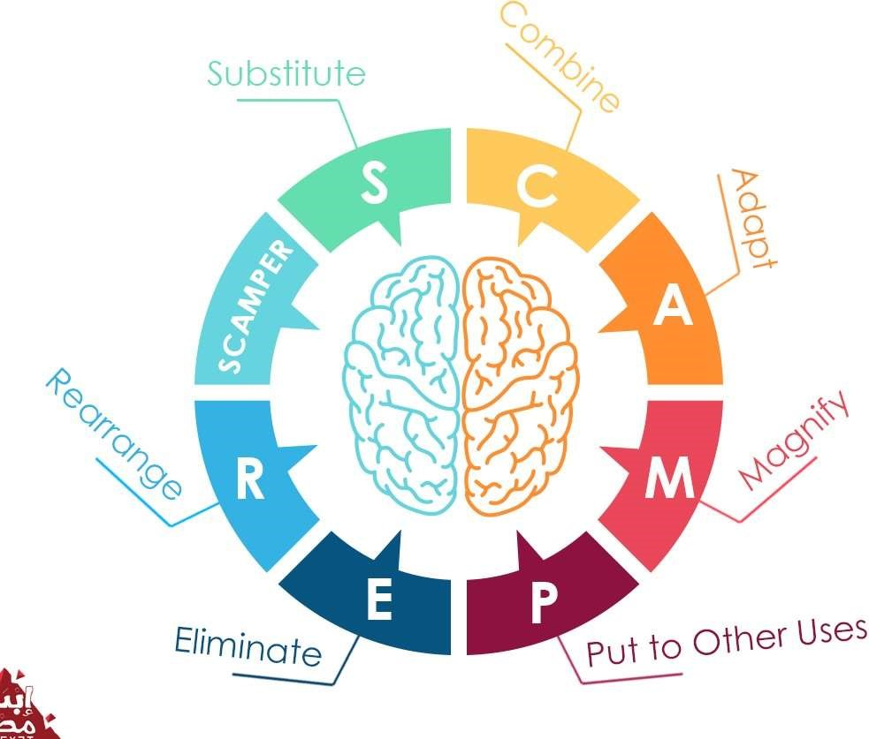

SCAMPER

4.2 Outcome of Ideation Phase

The solution is designed after careful study of responses obtained via google forms and mind mapping keeping in mind all the stakeholders to have a user-friendly experience and be feasible to all.

* + - A person who is either deaf/dumb can show gestures using hand.
    - These gestures are converted to corresponding statements/sentences.
    - Efficient machine learning algorithm is used to convert gestures into corresponding statements/sentences.
    - A normal person who wants to communicate to a person who is deaf/dumb can easily access this interface and communicate.
    - This algorithm can also be used as a secret code language for security purposes.

CHAPTER 5

# PROTOTYPE MODEL

5.1 Latent Needs Addressed

The Expense Tracker caters to latent needs by addressing two crucial aspects: security and privacy features, and advanced budgeting tools. Recognizing the significance of safeguarding sensitive financial information, the application prioritizes security by implementing robust measures to protect user data. Simultaneously, the inclusion of comprehensive budgeting tools addresses the latent need for effective financial planning and control. The application's budgeting features empower users to set, monitor, and achieve their financial goals, providing a holistic solution that not only respects privacy but also enhances the user's financial management capabilities.

5.1.1 Solution Prototype

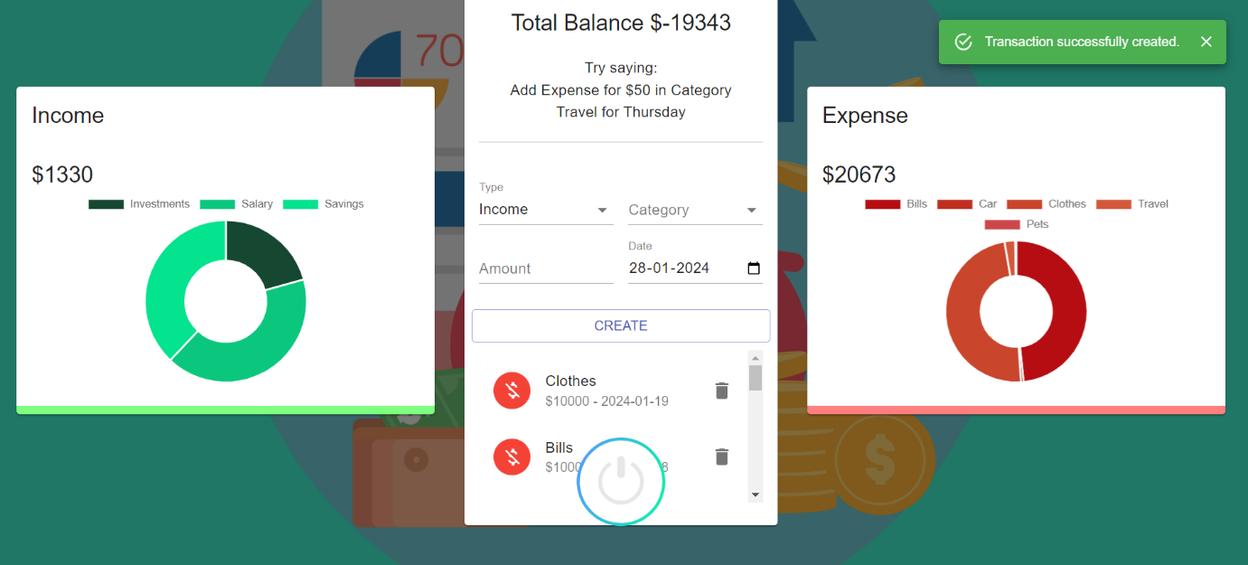

Figure 5.1.1: Input page for adding expenses

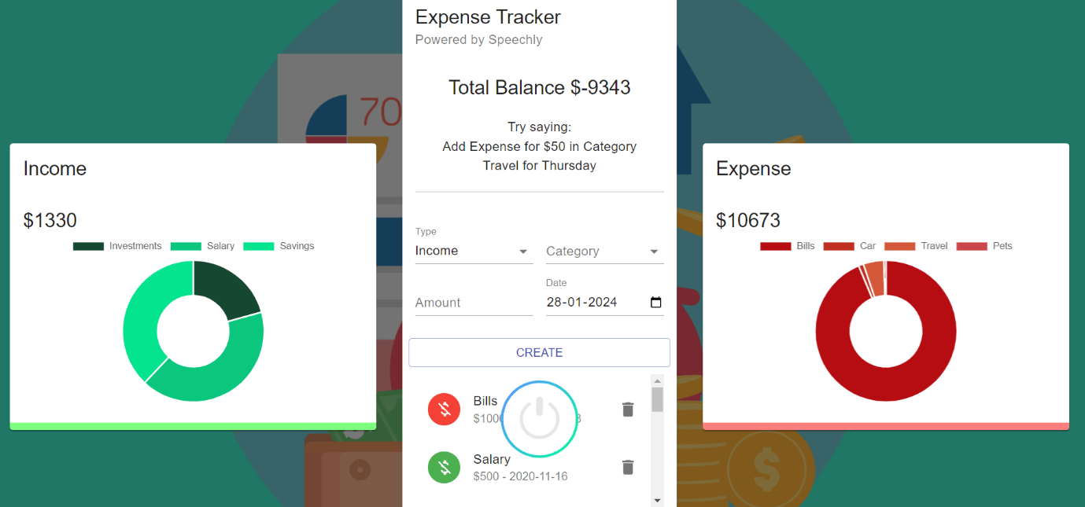

Figure 5.1.2:Analysis of expenses

5.2 Evaluation of prototype Based on Desirability, Feasibility & Viability

Desirability:

· The budget tracker System is very user friendly.

· Any person with basic internet knowledge can use it.

· It is desirable as it serves the purpose without making things complex.

Viability and Feasibility:

· This budget tracking system is built using MERN stack.

· Technically it is feasible and simple to implement using the latest technologies.

· This solution is economically feasible as well.

5.3 Design for Environment:

This solution is sustainable, it is easy to maintain in the long run.

It being a software will not wear out with time.

Any bugs identified in the process can be rectified and the software can be deployed again

CHAPTER 6

# CONCLUSIONS AND FUTURE SCOPE

6.1 Conclusion

The Expense Tracker Web Application tackles persistent challenges in financial mismanagement by presenting a user-friendly, efficient, and automated solution for expense tracking. This streamlined process not only simplifies financial management but also minimizes errors, providing a reliable system for individuals and businesses alike. Its user-friendly interface ensures ease of use, while automation enhances efficiency.

The application becomes an indispensable tool for those seeking to enhance their financial management practices. Through data visualization, users can quickly assess their expenses, gaining valuable insights into their spending patterns. This visual representation serves as an instant and intuitive way for users to make informed decisions, contributing to more effective financial control and planning.

6.2 Future Scope

Features that are yet to be implemented:

* Improvements are to be done regarding privacy.
* Adding remainders whenever expenses cross certain limit.

|  |  |
| --- | --- |
| References:    ●  ● | https://www.tillerhq.com/free-google-sheets-budgettemplates/#weekly-budget-worksheet-by-smartsheet https://www.tillerhq.com/free-google-sheets-budget-templates/#thebudget-that-helped-a-family-save-60-of-income    11 |